PROJECT DEVELOPMENT PHASE SPRINT - IV

|  |  |
| --- | --- |
| **Date** | 19-NOV-2022 |
| **Team ID** | PNT2022TMID40818 |
| **Project Name** | Natural Disaster Intensity Analysis and Classification using  Artificial Intelligence |

# INTEGRATE THE WEB APP WITH AI MODEL:

After creating the Model, the Model should be integrated with the web app using the Flask application. The coding part is named as app.py and it will be running in the localhost through the generated link. By navigating the localhost the webpage will be visible.

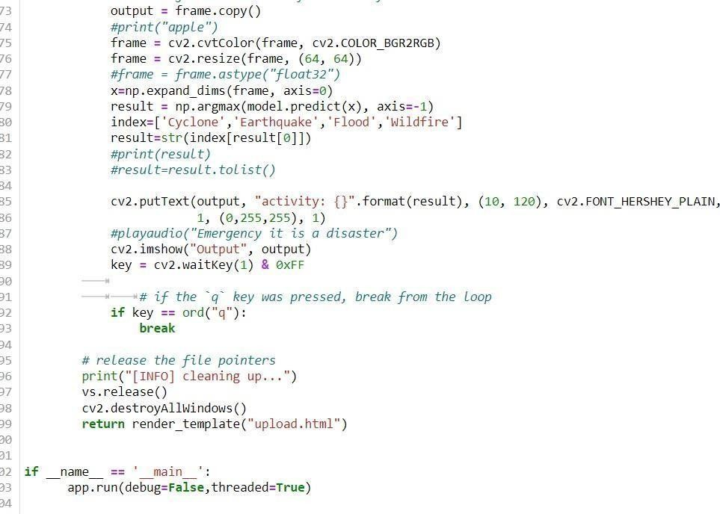

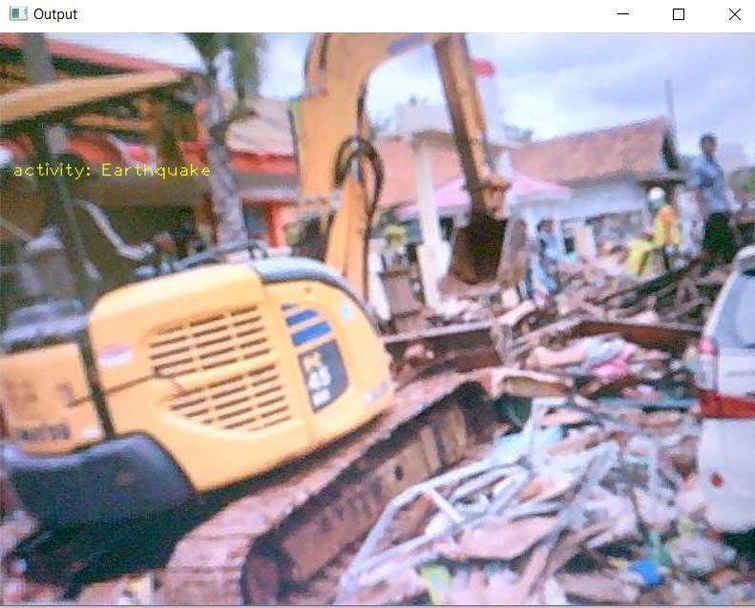

# MODEL DEPLOYMENT:

The trained model which is running in the localhost without any error is deployed in the IBM Cloud for making available for the users to predict the Disaster’s type and its intensity. It is integrated with the Flask application.

